

Local Government Association Local Industrial Strategy Support

Shared Intelligence June 2019

## Contents

**1.** **Background** 3

**2.** **Introduction** 6

**3.** **Why should councils engage with their Local Industrial Strategy?** 8

**4.** **What can councils contribute to a Local Industrial Strategy** 10

**5.** **What does effective Local Industrial Strategy engagement look like?** 13

**6.** **LEP Board Membership considerations** 21

**7.** **Eight questions to take stock** 22

**8.** **LEPs, LEP Boards and LEP Board Members: what the Government says** 23

LEPs 23

LEP Boards 24

Standards of conduct 24

# **Background**

The Government’s Industrial Strategy aims to: ‘boost productivity by backing businesses to create good jobs and increase the earning power of people throughout the UK with investment in skills, industries and infrastructure’.

In the Industrial Strategy, the Government sets out five foundations of productivity and its ambitions for each of these foundations:

* **Ideas** – the world’s most innovative economy
* **People** – good jobs and greater earning power for all
* **Infrastructure** – a major upgrade to the UK’s infrastructure
* **Business environment** – the best place to start and grow a business
* **Place** – prosperous communities across the UK

The Industrial Strategy then details a range of policies under each foundation that seek to support the ambitions of the strategy. One of the key policy announcements under the ‘Place’ foundation was the introduction of Local Industrial Strategies.

The Government has outlined that Local Industrial Strategies will:

* Promote the coordination of local economic policy and national funding streams;
* Establish new ways of working between national and local government, and the public and private sectors;
* Be based on clear evidence and aligned to the national modern Industrial Strategy; and
* Inform approaches to any future local growth funding and help local areas in England decide on their approach to maximising the long-term impact of the UK Shared Prosperity Fund.

The Industrial Strategy outlines that places in England with a Mayoral Combined Authority will have a single Local Industrial Strategy led by the mayor and supported by Local Enterprise Partnerships (LEPs). For parts of the country without a mayor, the development of the LIS will be led by the LEP.

The Government is aiming to agree Local Industrial Strategies with all areas of England by early 2020 and development will proceed within three waves:

* **Wave 1 “trailblazers” (announced in November 2017)** – Greater Manchester, West Midlands and the Cambridge-Milton-Keynes-Oxford Corridor.
* **Wave 2 (announced in July 2018)** – Cheshire & Warrington, Heart of the South West, Leicester & Leicestershire, North East, Tees Valley and the West of England.
* **Wave 3 (announced in December 2018)** – all remaining areas of England outside of Waves 1 and 2.

The West Midlands recently became the first area to publish a Local Industrial Strategy agreed with Government and the other trailblazer strategies are expected to be published shortly.

**Figure 1: Local Industrial Strategy areas by wave****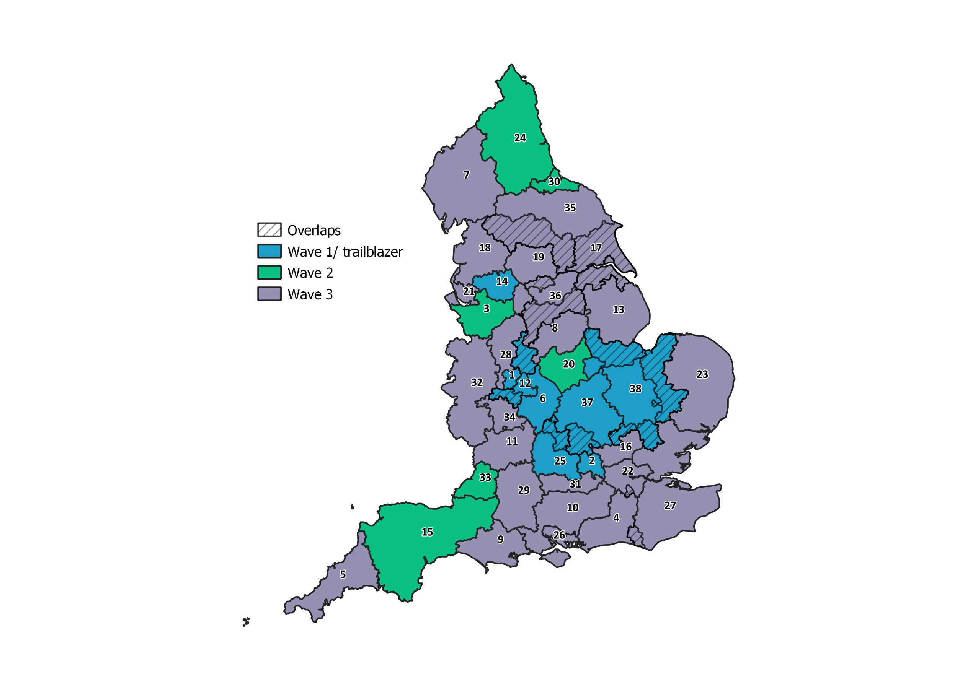**

1. Black Country

2. Buckinghamshire Thames Valley

3. Cheshire and Warrington

4. Coast to Capital

5. Cornwall and Isles of Scilly

6. Coventry and Warwickshire

7. Cumbria

8. Derby, Derbyshire, Nottingham and Nottinghamshire

9. Dorset

10. Enterprise M3

11. Gloucestershire

12. Greater Birmingham and Solihull

13. Greater Lincolnshire

14. Greater Manchester

15. Heart of the South West

16. Hertfordshire

17. Humber

18. Lancashire

19. Leeds City Region

20. Leicester and Leicestershire

21. Liverpool City Region

22. London

23. New Anglia

24. North East

25. Oxfordshire

26. Solent

27. South East

28. Stoke-on-Trent and Staffordshire

29. Swindon and Wiltshire

30. Tees Valley

31. Thames Valley Berkshire

32. The Marches

33. West of England

34. Worcestershire

35. York, North Yorkshire and East Riding

36. Sheffield City Region

37. South East Midlands

38. Greater Cambridge and Greater Peterborough

In response to the introduction of Local Industrial Strategies, the LGA commissioned two strands of complementary improvement support for local government and their partners to support them in the development of ambitious Local Industrial Strategies.

The two strands of support provided were:

* **Understanding and supporting the role of councils in LIS development –** this report captures the learning gathered from this strand of the support offer.
* **Exploring the ‘key ingredients of LIS development’** – outputs from this strand of the support offer are available here.

Further information on Local Industrial Strategies, and the LGA’s work in this area, can be found at: [www.local.gov.uk/localindustrialstrategies](http://www.local.gov.uk/localindustrialstrategies)

If you have any queries on the content of this report or the LGA’s future LIS support offer to councils, please contact [localism@local.gov.uk](mailto:localism@local.gov.uk)

# **Introduction**

Shared Intelligence was commissioned by the LGA to deliver an improvement support offer that sought to better understand the role of councils in Local Industrial Strategy (LIS) development and to support councils to initiate or further their engagement with their LIS.

This report seeks to capture the learning from this support offer and draws on the findings of a wide-reaching engagement exercise, which included interviews and facilitated group discussions with elected members, senior council officers, LEPs and national stakeholders. It also draws on the themes emerging from a series of action learning sets attended by council officers engaged with their LIS that were facilitated by Shared Intelligence.

In total during the research, Shared Intelligence spoke to 68 individuals, representing 63 organisations. A breakdown of the contributions included conversations with 51 councils, 7 LEPs and representatives from 10 national stakeholder organisations such as the LEP Network, Chief Economic Development Officer Society and District Councils Network.

Through this engagement, our headline findings were:

* While LEPs and Mayoral Combined Authorities have been given responsibility for producing the LIS, councils have an important part to play given their role as leaders of place with key delivery responsibilities and democratic oversight.
* While many council leaders see the health of their local economy as a high priority, they tended to see the LIS as a lower priority. This is in some part a result of a degree of uncertainty as to how Local Industrial Strategies can support local economic priorities, and in particular details of the powers and funding that will accompany them (e.g. the UK Shared Prosperity Fund).
* A council’s ability to participate fully in the LIS process hinges on the quality of the relationship between the council and the LEP. For areas where there is scope to strengthen this relationship, the LIS development process presents a vehicle through which to do this.

In response to these headline findings and in order to help councils across the country to consider their role and engagement in the LIS process, this report is structured around three sections that look to address the following questions:

**Why should councils engage with their Local Industrial Strategy?**

This section outlines the case to local government for playing an active role with their Local Industrial Strategy and the potential benefits this can bring.

**What can councils contribute to a Local Industrial Strategy?**

This section details the key areas where councils can add value to the successful development and delivery of ambitious Local Industrial Strategies.

**What does effective Local Industrial Strategy engagement look like?**

This section details practical steps that councils, in partnership with other local leaders including LEPs, can take to maximise their contribution to their LIS. This builds on the concept of the LIS being a vehicle through which local collaboration on economic development can be strengthened.

Throughout this report, we draw on local case studies and refer to external resources that complement this report. At the conclusion of the report, we have captured the government guidance for local authority politicians and officers and Local Enterprise Partnerships.

# **Why should councils engage with their Local Industrial Strategy?**

When asked, most council leaders say they see the health of their local economy as a high priority; however, when asked specifically about the LIS, they tended to give it a lower priority.

While we acknowledge this is in some part due to a degree of uncertainty as to how Local Industrial Strategies will be used, we would argue that the action a council takes to contribute to the LIS is very similar to the action it should be taking in any case to support its local economy. By ensuring that the LIS for its area is as strong as possible and aligned with established priorities, a council will ensure that its area is well-placed to benefit from the current government’s approach to local economic development.

This section outlines five reasons why councils should prioritise working with their LEP on the LIS.

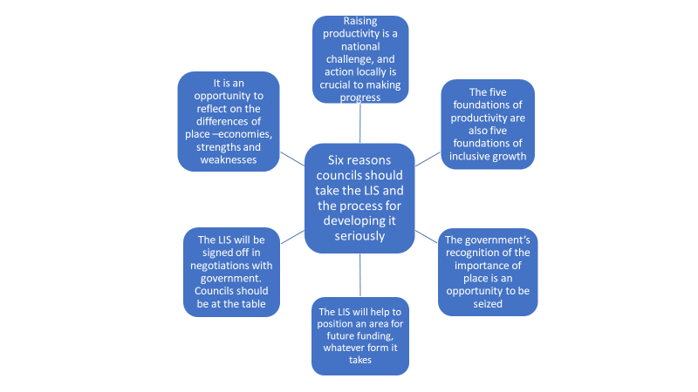**Figure 2: Six reasons why councils should take the LIS and the process for developing it seriously**

1. **Action to raise productivity is important in all local economies.** One important outcome of the LEP Review was the government’s decision to give LEPs a “single mission” to raise productivity. The LIS is the main vehicle for delivering that mission.
2. **The Government’s five foundations of productivity[1] –** **ideas, people, infrastructure, business environment and place are also key to supporting inclusive local economies**. Using the

foundations as a common framework for a family of strategies and plans can help secure a joined-up approach by councils, the LEP and other local partners.

1. **The government has emphasised the importance of place – a theme in the LIS on which councils should be setting the lead.** The government’s LIS prospectus says that the strategies should “set out the spatial impacts of national and local policy across our cities, towns, and rural areas: informing policies and choices and demonstrating how they will allow all communities to contribute to, and benefit from, economic prosperity.”
2. **It is clear that the government envisages that Local Industrial Strategies will influence future funding and investment decisions.** Councils will want to be in the best possible position to ensure their local priorities are reflected and to take advantage of whatever funding streams are available in the future including the new UK Shared Prosperity Fund.
3. **The process of finalising the LIS provides an opportunity for a negotiation with government.** Councils will want to ensure that government gets a good understand of the challenges and opportunities in their areas. This is particularly important in areas where LEPs cover several county and unitary councils and in areas where there are overlapping geographies.
4. **Reflecting on the difference between places within LEP geographies will strengthen the case for focus.** Through the evidence base, councils have an opportunity to work with their LEP to provide a granular detail at a hyper-local level. This approach will strengthen the LIS and ensure that priorities and any future investment is directed to raising productivity.

Each of these reasons taken individually provide a sound basis for council involvement in their Local Industrial Strategy. When considering all six reasons together, the case is overwhelmingly made for councils to ensure that their contributions are central to the LIS development.

In the next section, we set out what councils can contribute to the process, considering their role in shaping the identity of each place, the civic leadership required to ensure successful strategic development and their relationship with anchor institutions including business.

# **What can councils contribute to a Local Industrial Strategy**

While LEPs and Mayoral Combined Authorities are leading the development of Local Industrial Strategies, councils have a crucial role to play in their development and delivery. The role of councils stems from their leadership and responsibilities relating to their local economy and businesses but also through their representation as a key public sector partner and representative for their LEP.

This section captures a number of the key areas in which all councils can contribute to the successful development and delivery of successful Local Industrial Strategies. As they are produced, more learning around councils’ contributions will need to be captured and disseminated.

1. **Contributing to the leadership of LEPs through the role of council leaders as LEP board members and council representation on other LEP forums.**

The presence of local authority leaders on LEP boards, and involvement with other local economic joint decision-making forums, provides an important opportunity to ensure the development of effective Local Industrial Strategies that align with council priorities.

These forums, and the council role in them, will become all the more critical in those areas where public sector representation on the LEP board is set to reduce following the recommendations of the Government’s LEP Review.

If Local Industrial Strategies are to deliver on the Government’s ambition to establish new ways of working between the public and private sectors, it is critical that councils maximise their contribution to the LIS through both representation on their LEP Board and other joint decision-making mechanisms.

The next section of this report explores some of the joint forums that have been established in different parts of the country and also considers how councillors on LEP Boards can input meaningfully into the LIS process.

1. **Contributing as a key local anchor institution to the development of the strategy.**

Councils are key local anchor institutions and increasingly play an important role in mobilising the collective contribution of other local anchor institutions including, for example, universities, further education colleges and hospitals. This complements the role of LEP boards in bringing local partners together.

This working together of local anchor institutions can add value to the LIS in terms of:

* Evidence;
* Action to support local businesses;
* The institution’s role as local employers in their own right;
* Their role in commissioning services and procuring a variety of activities and services.

1. **Providing ultimate local democratic accountability for the strategy (except in areas with a CA), including the role of overview and scrutiny.**

A key feature of LEP boards is the bringing together of local business and political leaders to enable the development of strong and inclusive local economies. Council’s ultimate political accountability is essential to the legitimacy of LEPs and the actions they take. In order to fulfil their part of this key relationship councils can feed into their local community intelligence. Council cabinets should consider the emerging LIS. Most LEPs include more than one unitary or county councils and in many places, arrangements have been put in play to discharge this local democratic function collectively including, for example the Gloucestershire Economic Growth Joint Committee and the Association of Black Country Authorities.

Councils’ overview and scrutiny committees have an important role to play in scrutinising the process by which the LIS is developed and reviewing the implementation phase. In many areas, councils have established joint scrutiny arrangements to provide a LEP-wide approach to scrutiny involving, for example, county and district councils.

1. **Providing hands-on support to the LEP in developing the strategy. The nature of the support will vary depending on local circumstances including the balance of capacity, skills and resources between the LEP and the councils.**

The capacity and capability required to deliver the LIS within the LEPs varies significantly from geography to geography. Councils can not only bring resource but a vision and a history of strategy development. Where roles and responsibilities have been defined from the outset and are clearly articulated with wider partners, combined resources will be more valuable.

This is increasingly prominent in second and third wave areas, where a more collaborative approach is being taken on the evidence base development. An example of best practice in this regard is highlighted earlier / later in this report in the case of Cheshire and Warrington councils. The three councils within the LEP area prepared ‘hyper-local’ LIS have contributed to the overall evidence base, enabling councils to highlight and set out priorities. This has also been a strong feature in Gloucestershire where the infrastructure foundation lead is a senior council officer.

1. **Deploying their strategic, regulatory and delivery roles, including responsibility for infrastructure, housing and planning.**

Councils have a wide range of roles and responsibilities which are relevant to the development and delivery of a local industrial strategy. These include:

* Their regulatory responsibilities, including trading standards and environmental health, which contribute to the local business environment;
* Their education and skills roles including their statutory responsibility for education and their wider relationships with schools and further and higher education;
* Their planning, transport and infrastructures responsibilities;
* Their wider health and wellbeing roles including the duty on the adult social care function to shape the local care market.

Councils will have data from fulfilling these roles which will help to inform the development of the LIS. The LIS itself will need to be clear what part these roles have to play in helping the LEP and its partners to achieve the objectives set out in the LIS.

The need to provide inclusive growth leadership to ensure a continued focus will be an ongoing priority for councils and Combined Authorities. This links to the need to ensure when priorities for funding through the likes of UK Shared Prosperity Fund come about, councils are in a position to inform local programmes and drawn down funds accordingly.

1. **Acting as the ‘glue’ in the process and providing a source of distinctive and constructive challenge**

In addition to their statutory roles and responsibilities councils have a crucially important community and place leadership role. Sitting alongside business leadership providing by the LEP, this can provide “glue” in the process ensuring that the industrial strategy complements other strategies, including health and wellbeing. Councils are also well-placed to act as a source of constructive challenge for the LEP to ensure that the LIS genuinely reflects local needs and circumstances.

1. **Acting as the custodian of place with a history of place-shaping and identifying priorities required to support the resident and business base.**

A long history of place-shaping, whether through direct statutory planning such as creation of the Local Plan / Joint Core Strategy, Local Transport Plans or contributing to the wider place-making agenda such as contributions through Sustainability and Transformation Plans, councils are front and centre to guide priorities important for LIS development.

Councils as custodians of place are also focused towards residents and council tenants. Ensuring that the needs of this local population, by bringing forward employment, providing housing and community infrastructure must be factored in. Finally, this place-shaping must align with other strategies to ensure a ‘family of strategies’ approach.

How these roles are delivered will inevitably vary depending on the context including:

* The nature of the council and whether it is part of a combined authority;
* The different roles and responsibilities of unitary, county and district councils;
* The presence of established decision-making structures;
* The level of evidence already used for plan making; and
* The number of councils within the LEP area.

While this section set out some roles’ councils need to play and the contributions they can make, there will be other ways of influencing and supporting the development of the strategy. The next section of this report looks in more detail at the engagement required to ensure this LIS is truly a co-produced document with close ties to anchor institutions and strong engagement.

# **What does effective Local Industrial Strategy engagement look like?**

A Council’s ability to participate fully in the LIS process hinges on the quality of the relationship between the council and the LEP. As council leaders are important members of LEP boards the objective should be to move toward a situation in which the LEP is “us” and the LIS is “ours”.

Achieving a good “us and ours” position is important providing the foundations for a coherent engagement with government on the LIS. It should enable the place to speak with one voice, with the potentially to influence future funding decisions

This paper includes some good practice examples of the council/LEP relationship, but it is important to remember that long term relationships between local political and business leaders are critically important whatever the current organisational framework.

This section outlines six steps of LIS development which should help to create the conditions in which the LEP is an “us” and the LIS is “ours”. It also provides a self-assessment checklist which councils can use to benchmark their own progress and strength in relationship with their LEP.

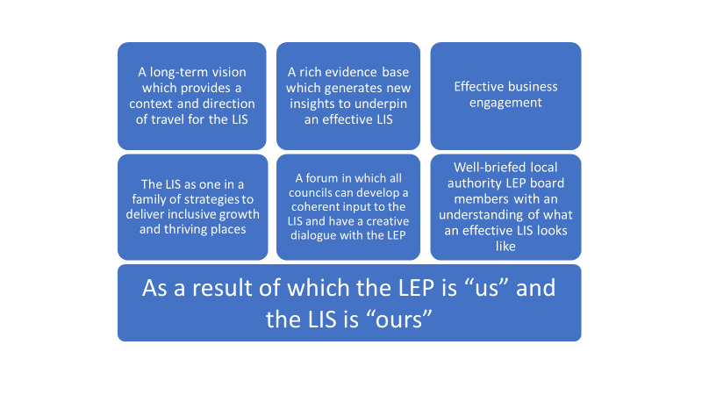

**The six steps**

**1. A long term vision for the place which provides a context and direction of**

**travel for the LIS**

The starting point for an effective LIS is a long-term vision for a place. This is likely to be wider in scope than a LIS, often providing the context for other local strategies including the health and wellbeing strategies and the local planning framework. The long-term nature of the vision is important, providing a wider context and direction of travel for the area, enabling it to take advantage of individual initiatives such as the development of Local Industrial Strategies. A vision of this type is likely to be owned by the full gamut of local stakeholders, including the LEP.

“We are beginning to appreciate how economic strategies could sit alongside the LIS but reflect our own Council’s additional priorities” Senior Council Officer, Suffolk

|  |
| --- |
| **Case Study – Developing a long-term vision**  The Black Country LEP has had the benefit of working within the context of a long-term vision for the Black Country which was developed in 2003. In Gloucestershire *Leadership Gloucestershire,* which comprises all the councils and partner organisations in the county, including the LEP, has recently developed a vision for 2050. The Black Country’s vision is for 2033. It was developed by the Black Country Consortium, a long standing public private partnership, and was adopted by the Association of Black Country Councils. The vision underpinned the development of the Black Country Joint Core Strategy, the Black Country City Deal and the Black Country LEP’s strategic economic plan. The vision was reviewed by the Black Country LEP Board in December 2017 and provides for context for its contribution to the development of the West Midlands Combined Authority’s strategic economic plan and local industrial strategy. The key elements of the vision provide the core of the performance management framework against which the LEP measures the impact of its activities.  Leadership Gloucestershire has worked with the University of Gloucestershire to develop a vision for Gloucestershire as a “great place to live, work and do business, with a thriving future. The vision was informed by a Big conversation which attracted over 2,500 contributions from organisations and individuals in the county. It is envisaged that a range of organisations will deliver the vision, including the LEP and the Gloucestershire Economic Growth Joint Committee. It also establishing three new place-based boards to lead the delivery of the vision in different parts of the county. |

Questions to consider:

* Does your council have a long-term vision?
* Have council partners bought into this vision?
* How does this vision fit or complement the vision of the Local Enterprise Partnership and the emerging Local Industrial Strategy?
* Has the council been involved in setting the Local Industrial Strategy vision at an officer and member level?

1. **An evidence base which generates new insights to underpin an effective LIS**

There is a common understanding across all councils and LEPs that Local Industrial Strategies must be built from the bottom up through the development of a robust evidence base to drive a crisp set of priorities and propositions. This evidence base must be data led but grounded by the reality of local partners through a process of ‘early and often’ engagement with key stakeholders, not exclusively delivered by the LEP but with council leadership jointly leading the discussions. Engagement with local stakeholders and anchor institutions such as health and education partners can generate supplementary evidence and different insights to support the LIS. The evidence should lead to the identification of a small number of nationally significant assets or strength in sectors and a set of priorities which will ensure the locality is prepared for economic shocks.

“Inclusive growth agenda has been central to the evidence base thinking”

Member, Tees Valley Combined Authority

Questions to consider:

* Has the council provided strategies and core evidence that can support the LIS creation?
* Has the LIS evidence base been presented to ensure the ‘data’ matches with the requirements on the ground?
* Have anchor institutions been asked to contribute to the process?

1. **Effective engagement with business, anchor institutions and government** (See also the LGA report on Developing Successful Local Industrial Strategies)

The role of engagement is a joint responsibility, and this comes in many forms. While the LEP may lead on large scale business engagement, including facilitating sector groups or networks, councils have their own relationship with businesses and other strategic employers such as those from health (the NHS, CCG), education (local universities and colleges as well as adult education) and in their own supply chain (commissioning models). Coordinating this engagement will strengthen the LIS and make effective use of resources across both the LEP and councils.

This is coupled with engagement with government departments to ensure that the LEP can present a single set of messages in a consistent manner to ensure the agreed propositions can be prioritised and drive local investment. Ongoing relationship building with Whitehall will also be crucial to keep abreast of the latest thinking on the shape and scope of a LIS and understanding the forthcoming opportunities such as those which might be generated through the spending review and mechanisms to ensure fair funding through the forthcoming opportunities of the Shared Prosperity Fund.

“all of the issues raised so far through LIS development have resonated with our health partners, hospitals, GP surgeries etc.”

Health Partner, National Stakeholder Roundtable hosted by LGA

|  |
| --- |
| **CASE STUDY – Effective decision-making – Oxfordshire with OxLE**P  Oxfordshire is one of the government’s Local Industrial Strategy trailblazer areas and OxLEP has been leading on the creation of the LIS. The approach taken to the development of the LIS has been bottom up and locally designed to ensure a strong place narrative. The councils in the area have been a major part of the process. A strategy group with chief council officers has been established to co-develop the LIS with input from universities, UK Research and Innovation (UKRI) and Catapults. This group then feeds back to the LEP and into the LIS.  At a strategic level, the Oxfordshire Growth Board is used as the vehicle for information sharing and decision making about the content of the LIS and ensures effective collaboration between the partners. This board is a joint committee of the six councils in Oxfordshire, combined with other anchor institutions and the LEP. As not all councils are represented on the LEP Board, this vehicle is ideal to ensure that all councils are able to access timely information and support the overall decision-making. Given the priorities are so inextricably linked, this forum can consider wider implications and opportunities in areas such as economic development, strategic planning and growth.  The Growth Board secured £215 million of funding from the government in a Housing Growth deal in the November 2017 Budget. This deal intended to provide for new homes and new infrastructure across the LEP area, with £60 million of the funding going to housing and £150 million going to infrastructure projects. The housing growth deal also has £5 million set aside for meeting the costs of the investment programme. This includes the development of a Joint Strategic Spatial Plan which is a central contributor to the place foundation of the LIS. The concurrent development of the LIS is expected to lead to significant economic growth within Oxfordshire. The LEP and the Growth Board together have ensured the building blocks are in place and that the integration of all plans is undertaken in a way which is tried and tested. Both the LEP Board and the Growth Board are seen as the two necessary vehicles for taking this forward. |

Questions to consider:

* Does the council and the LEP have consistency of message in meetings and on platforms with other stakeholders?
* Has the council offered to involve its own stakeholders in LIS development?
* Have conversations between the council and other government departments reinforced the joint working and joint priorities of the council and the LEP?

1. **The LIS as one in a family of strategies to deliver inclusive growth and thriving places**

The LIS is likely to be one of a family of strategies. In large LEPs, complementary local strategies may be in place with a strong place dimension. In other areas parallel inclusive growth strategies may be developed. If this notion of a family of strategies is to be effective there must be a shared understanding of how the different strategies fit together to complement the overall vision and prioritisation of resource. Councils have an array of evidence and strategies which can contribute to the overall narrative, particularly holding the pen on the overall place narrative. Equally, there is a responsibility to ensure that future planning and strategy development can learn from the LIS and build on its successes. This approach can also facilitate an effective relationship between economic growth strategies and the statutory planning process, bringing together a deliverable set of priority actions.

Inclusive growth is a topic of much debate, in part because the concepts of generating higher levels of productivity are not always considered central to the inclusivity agenda. While inclusive growth is not a new concept, the foundation of productivity relating to skills is considered most important by councils in ensuring that the two agendas can come together to deliver greater social mobility and opportunities for all communities. This needs to feature through the evidence base to identify tangible ways of addressing disparity and alternative routes for councils to address it.

“(there) has been a directive from the councils not to pick the winners and ignore the rest” Senior Officer, Swindon and Wiltshire

|  |
| --- |
| **CASE STUDY Complementary Strategy Development – Cheshire and Warrington**  The Cheshire and Warrington LEP covers three Unitary Authorities. Before the LEP was formed there was already a history of strategic decision making in the region, with a strategic commission having been in place for several years. This meant that the formation of the LEP went smoothly, as existing structures were already in place. council are heavily involved in developing the LIS and, despite being under different political control, they often reach a consensus on economic growth. Differences are more likely to reflect geography than policy. Building on this, the LEP has implemented pre-meetings and discussions to prepare for key decisions. The fact there has never been a vote on a decision demonstrates the effectiveness of these arrangements.  To maintain this working relationship, it is essential to have effective collaborative arrangements in place collaboration as this ensures that potential disagreements can be identified, and a consensus established. To develop the LIS a steering group has been created with the LEP, three Local Authorities, and the consultants who are supporting the work. Additionally, there is a sub-regional leaders’ board and an economic directors board, both of which consider LIS related matters and issues which arise. The effectiveness of these relations hinges in part of the fact that only three councils are involved, but they also reflect the long-term relationship between the key organisations. This enables constructive challenge when appropriate, for example over local attention to the rural economy.  The LEP has given each of the three Local Authorities £25,000 to produce their own ‘hyper-local’ Industrial strategy. This is intended to act as a bottom up counterbalance to the top down Industrial Strategy framework from the government. These strategies provide a system for including priorities which would not fit centrally within the LIS framework, such as Inclusive Growth. These strategies underpin the relationship between the Councils and the LEP and drive everything they do, not just for the LIS process, but beyond. This reduces the scope for arguments over what is and is not included in the main LIS document, enabling a focus on both LEP wide and more local issues. |

Questions to consider:

* Is the LIS seen as part of a family of strategies?
* Is there a shared understanding with the LEP about how plans and strategies developed by the council, on for example inclusive growth or for particular areas, relate to the LIS?

1. **A forum in which all councils can develop a coherent input to the LIS and have a creative dialogue with the LEP**

A range of governance vehicles have a part to play in developing the LIS. The primary responsibility lies with the LEP Board (except where there is a Combined Authority structure). A key task for councils is to ensure that local authority LEP board members understand their role on the board, are well-briefed and can report back to any councils in their locality which are not directly represented on the board.

In many areas a growth board or statutory joint committee has been established bringing together council leaders and/or relevant portfolio holders. Fora such as these can provide a mechanism for developing a coherent local government input to the LIS process particularly in LEPs which cover a large number of councils, including two tier areas. In many areas the LEP chair and/or vice chair are members providing an opportunity for a collective dialogue with them.

At a more operational level, many areas have meetings of directors or heads of regeneration and/or economic development across LEP areas in which LEP officials also participate. Some LEPs have set up steering groups or task and finish groups to oversee the development of the LIS. It is important that councils are appropriately represented on these bodies.

Despite coming from different political parties, they (Members) generally reach consensus on important local matters

Senior Council Officer, Cheshire & Warrington representative

|  |
| --- |
| **CASE STUDY 4 – Joint Committee structure – Heart of the South West**  The Heart of the South West LEP area covers Devon, Somerset, Plymouth and Torbay. There are 17 councils in the LEP area in total, in addition to several other major organisations. The mechanism that has been developed to support the creation of a vision and for ensuring collective decision-making is in the form of a Joint Committee. This committee includes representatives from the 17 councils and a further six anchor organisations. The Heart of the South West Joint Committee and the LEP have worked together to develop and agree a “Productivity Strategy” for the region.  The Heart of the South West Joint Committee was formed in early 2018 with the first order of business relating to strategy parameters and development. This joint strategy was designed to double the productivity in the area over the next twenty years through targeting specific sector opportunities such as aerospace, marine, nuclear, energy and high value tourism. The specific benefit of the Heart of the South West Joint Committee is that councils can work across administrative boundaries to deliver meaningful and actual change, beyond what each council could achieve on its own. To achieve this, individual council boards, such as business boards, report to both their council and the Heart of the South West Joint Committee. The LEP also works closely with the committee on this, while the committee support the development of the LIS.  There is an ongoing arrangement between the LEP and the joint committee to work on the LIS together, with both bodies overseeing the work. This is beneficial for the LEP as they are reliant on a lot of council evidence. Although the LIS is still in progress (at the time of writing), the Heart of the South West is working with Government on further policy agendas including devolution. |

Questions to consider:

* Is there a forum in which councils covered by your LEP can have collective discussions and is the LEP involved in those discussions?
* Is there a forum for bringing together senior local authority officers responsible for economic development across the LEP area with the LEP team?

1. **Well-briefed local authority LEP board members with an understanding of what an effective LIS looks like**

“…led by influential private and public sector leaders, acting as champions for their area’s economic success”

“They provide political accountability and community knowledge”

LEP boards “must be able to take into consideration a breadth of interests of different local leaders and stakeholder groups”

**Government statements on LEP boards and council board members**

The presence of local authority leaders on LEP boards provides an important opportunity to ensure the development of effective Local Industrial Strategies. Government statements and guidance (summarised later in this report) highlights the leadership and governance role of LEP boards and the key role that local authority representatives should play on those boards, “bringing political accountability, local intelligence and local government delivery capacity.”

In most areas, however, action is required to mobilise this potential more effectively to ensure that LEPs, councils and, most importantly, local communities and businesses get maximum benefit from the current arrangements. Barriers can include:

* The absence of a shared understanding and expectation of the contribution of different members of LEP boards;
* Concerns about potential conflicts of interest arising from senior councillors’ different roles and responsibilities which in some cases have been compounded by the move to the incorporation of LEPs;
* The challenge of engaging councils which are not directly represented on LEP boards.

The attached note summarises recent government statements and guidance on the role of LEPs, LEP boards and local authority LEP board members. It also refers to the LEP assurance framework and governance principles. This provides a strong platform for local councils to have a powerful, confident and collaborative voice on LEP boards.

**Imagine a place where the LEP is “us” and the LIS is “ours”.**

**Imagine a LEP featuring in the long-running Radio 4 series, *The Archers….***

The leaders of Borchestershire, Felpersham and Borchester councils are active members of the Borchestershire and Felpersham LEP. They regularly meet the chair of the LEP, the managing director of one of the country’s largest food processes company based in Felpersham.

All the council leaders of the area are members of the Borchester and Felpersham Economic Joint Committee which is also attended by the LEP chair and vice chair. It provides a forum for debate and collaboration on action to enable economic growth in the area, supporting the councillor LEP board members, marshalling the council contribution to growth and ensuring that the LEP chair and vice chair have a good understanding of the position and contribution of local government.

The joint committee has developed a 2030 vision following extensive stakeholder and community engagement. It provides the strategic context for the Local Industrial Strategy. Felpersham City Council is developing an inclusive growth and regeneration strategy which is seen as part of a family of strategies for the area. It will both support the delivery of the LIS and ensure that all communities in the city benefit from economic growth and that long standing barriers to employment in parts of the city are addressed.

The LEP has established a subgroup to oversee the development of the LIS on which two of three council leaders sit. An officer steering group has also been established which is co-chaired by the LEP director and the chief executive of the county council. The economic development officers meet regularly with the LEP director and are working closely with the consultants commissioned to support the drafting of the LIS. The chief executive of Borchester Borough Council chairs the LEP’s place group which is contributing to the production of a joint core strategy for the area.

The LEP director regularly attends meetings of the Borchester and Felpersham chief executives’ group and the wider public sector partnership which also includes health, police, further and higher education and the voluntary and community sector.

# **LEP Board Membership considerations**

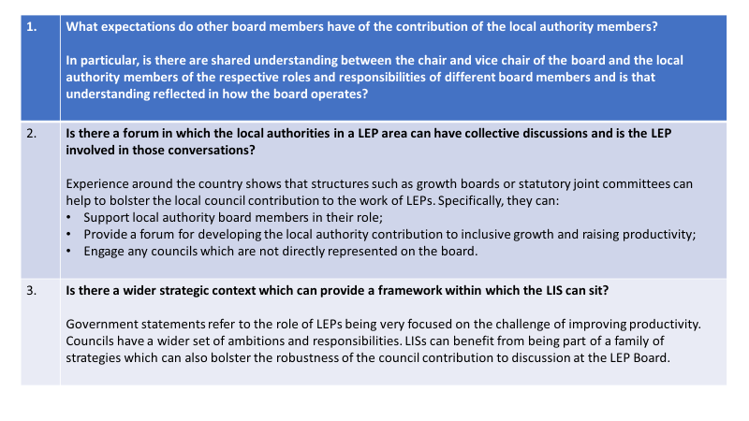The following three questions are intended to help local authority LEP board members to reflect on how whether they are making the most of their board membership.

# **Eight questions to take stock**

We have identified eight questions to enable a council to take stock of its contribution to the development of the local industrial strategy for its area including the nature of its engagement with its LEP.

1. Is there a shared vision for the future of the area covered by your LEP which can provide the context for its Local Industrial Strategy?
2. Does your council have a vision for the future of its area which can inform your contribution to the Local Industrial Strategy?
3. Is the LIS seen as one of a family of strategies (by place and or theme) to pursue inclusive growth in your area?
4. Are the local authority members of the LEP board briefed on what your council is seeking to achieve through the LIS, and do they report back?
5. Is local government appropriately represented on any structures the LEP has established to steer and contribute to the development and approval of its LIS?
6. Is there a forum in which the councils in the area covered by your LEP can have collective discussions and is the LEP involved in those discussions?
7. Is there a forum for bringing together senior local authority officers responsible for economic development across the LEP area with the LEP team?
8. Has/will your council have an opportunity to contribute to the evidence base for the LIS and to discussions on the insights that can be generated from it?

# **LEPs, LEP Boards and LEP Board Members: what the Government says**

This note summarises current government advice on the role of LEPs and LEP Boards, the role of LEP board members and the principles they are expected to work within. It draws on two sources:

* The National Local Growth Assurance Framework, published by the Ministry of Housing, Communities and Local Government in January 2019 (the “framework”);
* Strengthened Local Enterprise Partnership, the report of the review of LEPs, published by MHCLG in July 2018 (the “review”).

The note sets out the government’s view of:

* The role of LEPs and Local Industrial Strategies;
* The role of LEP boards including local authority members;
* The assurance framework within which they are expected to operate.

## LEPs

“LEPs prioritise policies and actions on the basis of clear economic evidence and intelligence from businesses and local communities. Their interventions are designed to improve productivity across the local economy to benefit people and communities with the aim of creating more inclusive economies.”

This is a crisp definition of the role of a LEP from the review report. It goes on to say that the Government has set LEPs “a single mission to deliver Local Industrial Strategies to promote productivity. This should include a focus on the foundations of productivity and identify priorities across Ideas, People, Infrastructure, Businesses Environment and Places.”

The framework sets out four activities the government says that “LEPs should focus on…to support the development and delivery of their LIS.” Those four activities are:

* Strategy “developing an evidence-based LIS that identifies local strengths and challenges, future opportunities and the action needed to boost productivity, earning power and competitiveness across their area;”
* Allocation of funds: identifying opportunities, prioritising the award of funding and monitoring and evaluating its impact;
* Using their convening power to bring together partners from the private, public and third sectors;
* Advocacy, working with partners “to act as an informed and independent voice for their area”.

Each LEP is expected to produce a LIS and an annual delivery plan and end of year report.

## LEP Boards

“Successful LEPs are led by influential private and public sector leaders, acting as champions for their area’s economic success.”

This is the ambition set out in the review report. The framework goes on to say that the LEP board should be “Comprised of public and private sector members who work collaboratively to ensure that decisions are made in the interests of promoting inclusive growth, prosperity and improved productivity in the local area and beyond.”

The review report notes that the Industrial Strategy highlighted the role for communities in driving productivity and that “LEPs must therefore be accountable to their area and representative of the communities they serve.” It adds that “LEP boards “must be able to take into consideration a breadth of interests of different local leaders and stakeholder groups to ensure that their growth strategies are relevant, representative and widely supported across their area.”

Much of the guidance relates to the role of business board members, including the chair and deputy chair. The framework, however, states that the purpose of the local authority representatives on the board is “to ensure democratic accountability and provide local intelligence.”

The review report states: “Businesses provide essential market intelligence to inform local decision making. Councils are also critical. They provide political accountability and community knowledge. They support business growth through their statutory functions, investment in economic infrastructure, and a wider role in creating quality places.”

Representatives from the private sector must form at least two thirds of the board. The framework adds: “In places where not all local authorities are represented directly on the LEP board it is important that their representatives have been given a mandate through arrangements which enable collective engagement with all local authority leaders.”

## Standards of conduct

The framework sets out five principles which should be met through each LEP’s Local Assurance Framework. One principle refers to “active cooperation” with stakeholders and other regeneration organisation which, the framework explains, “involves engaging deliberately and constructively with the private sector and public sector” including local authorities.”

Compliance with the Seven Principles of Public Life (the Nolan Principles) underpin the assurance framework. They are: Selflessness, integrity, objectivity, accountability, openness, honesty and leadership.

Each LEP is required to have a published conflict of interest policy which the framework says “must include details of how scenarios of potential conflicts of interest of local councillors, private sector and other board members will be managed whilst ensuring input from their areas of expertise in developing strategies and decision making, without impacting on good governance.”



[Shared Intelligence](https://sharedintelligence.net/our-people-3/lisa-mccance/)

Three Tuns House

London Bridge

SE1 1YU

|  |  |  |  |  |  |  |  |  |  |  |  |  |
| --- | --- | --- | --- | --- | --- | --- | --- | --- | --- | --- | --- | --- |
| |  |  | | --- | --- | | T: | [**020 7756 7600**](tel:020%207756%207600) | | W: | [**www.sharedintelligence.net**](http://www.sharedintelligence.net/) | |  | |  |  |  |  |  |  | | --- | --- | --- | --- | --- | --- | | |  |  |  |  |  | | --- | --- | --- | --- | --- | | Follow us: | |  | | --- | | [LinkedIn](https://www.linkedin.com/company/shared-intelligence) | | |  | | --- | | [Twitter](https://www.twitter.com/sharedintel) | | | | |
|  |

1. Set out in the government’s Industrial Strategy